NAME : Arjun Sehgal , Akshit Shah, Vatsal Shah
Roll : 1811041, 1811042, 1811052
Subject : OSPTL
TOPIC : HOSPITAL MANAGEMENT SYSTEM (USING TKINTER )

DESCRIPTION :
The system has four functionalities:
1)Add an appointment
2)Update an appointment
3)Delete an appointment
4)view the appointment
There are TOTAL 3 different window connected with MASTER.py ( MASTER IS THE MAIN WINDOW)
1)ADD appointment
2)UPDATE and DELETE appointment
3)View appointment

HOW TO USE THE SYSTEM :
STEP 1) RUN THE MASTER.py :
OUTPUT : This will open a login window
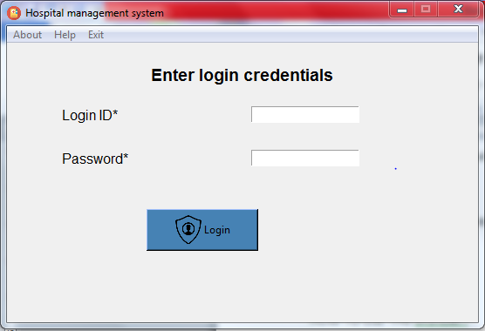

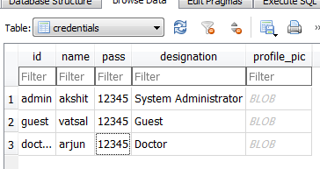
This is the database table used for loggin :
STEP 2 :LOGIN with any of the credential given in the database table
HERE logged in as arjun
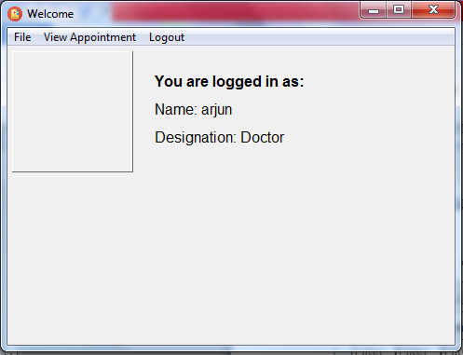
TOTAL FUNCTIONALITES ARE GIVEN IN FILE
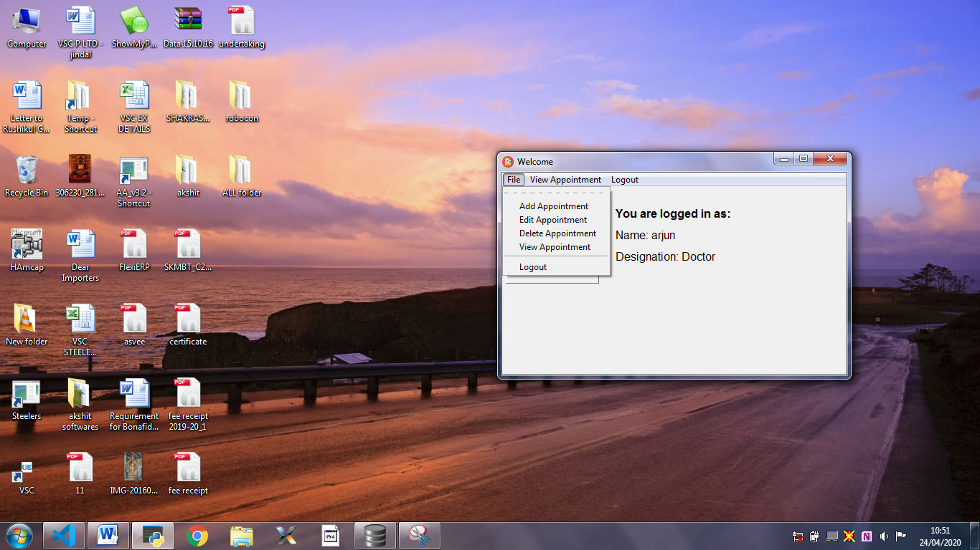
ADD APPOINTMENT WINDOW:
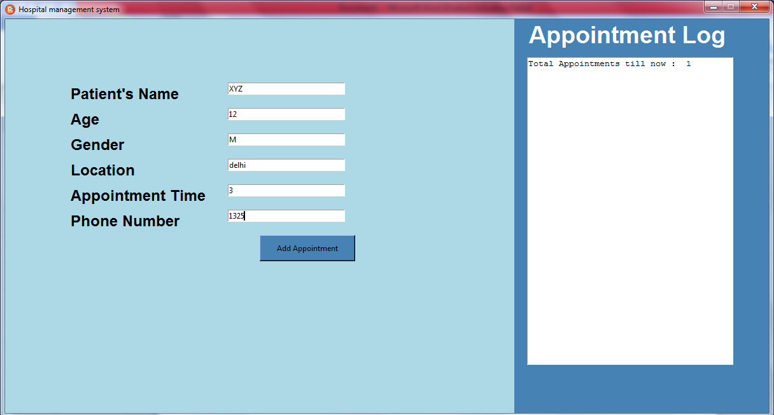
CLICK Add appointment :
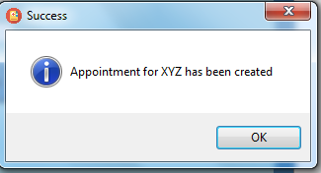
The data stored in appointments table :
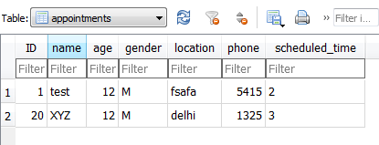

UPDATE/DELETE window:
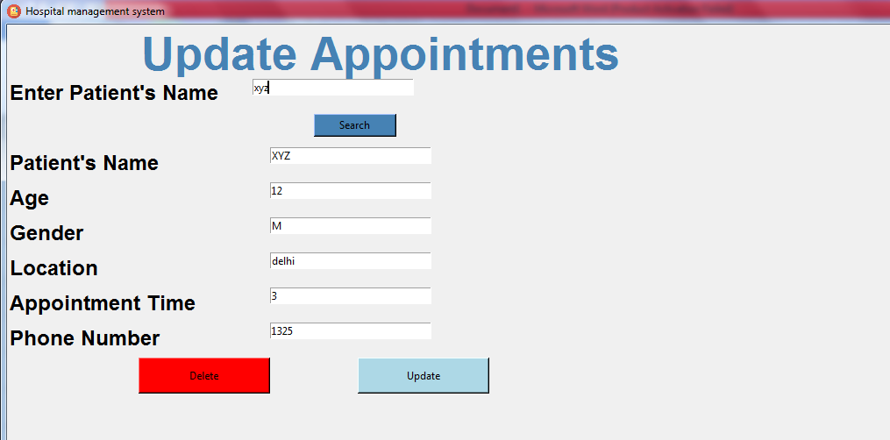
Changed appointment time to 5 and age to 13

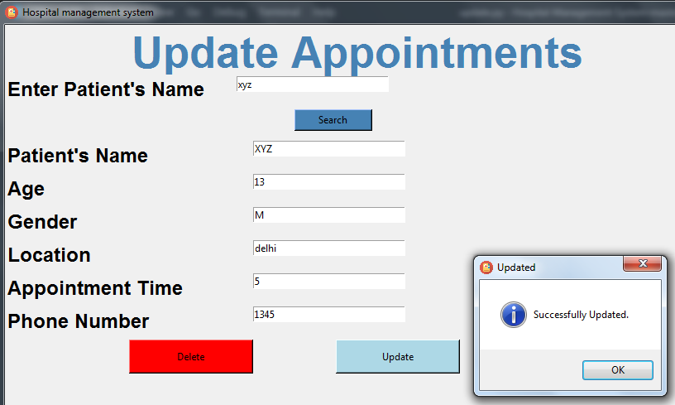
DATABASE UPDATED :

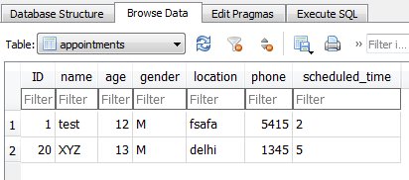
The ID is 20 because it is auto incremented forever, and while testing we had created and deleted between 18 accounts. But now it is again reset to 1.

Appointments Page :
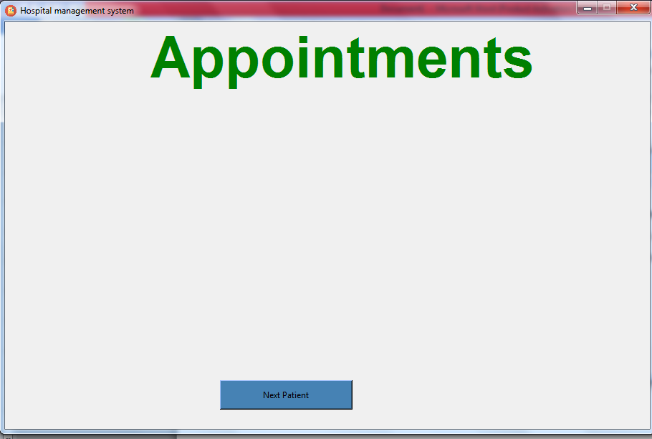
CLICK ON NEXT :
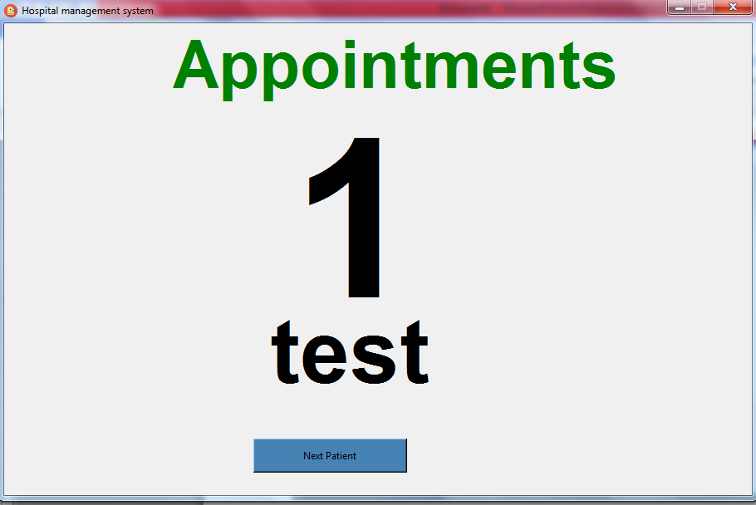
CLICK ON NEXT ;
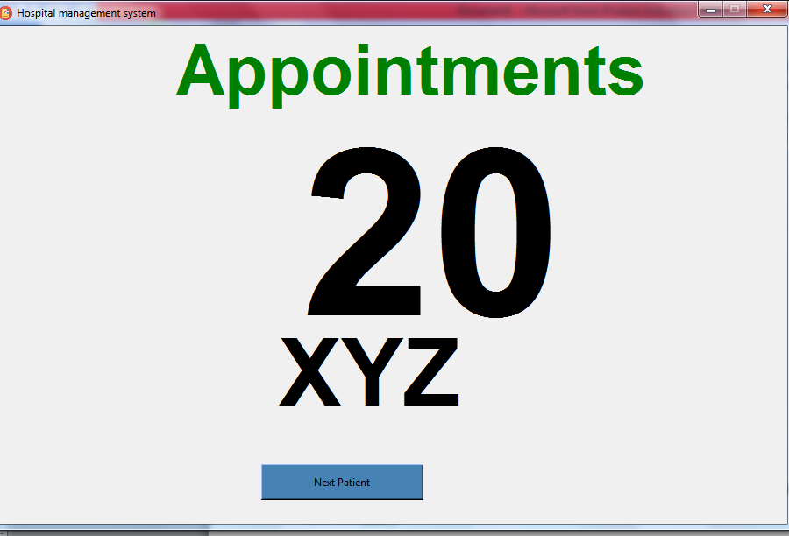
DELETING an Appointment :
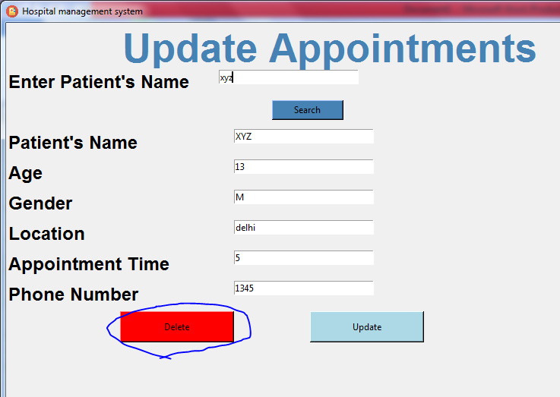
Also deleted from database :
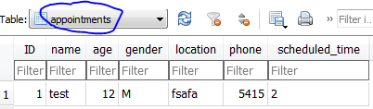

Libraries used :
tkiner : for GUI
os : to open new windows
sqlite3 : for connection database
pyttsx3 : for speaking the appointments (it works only if all the modules are properly supported in the device )
PIL : used to show the image of the user. (But its not yet working)

SOFTWARES USED :
- Visual studio code : To write code
- DB browser ( SQlite) : To operate DATABASE

